Open Concave-Looking Polygonal Chain
# Source: AI Source: Provided by: [Data Path: Persons Table -> ID Column: 1, Name_En Column: Motasem Essam] -> From: [ChatGPT] on [7/25/2026]
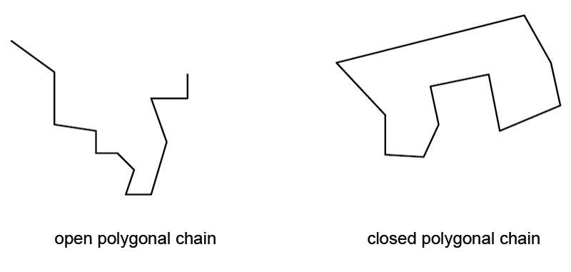
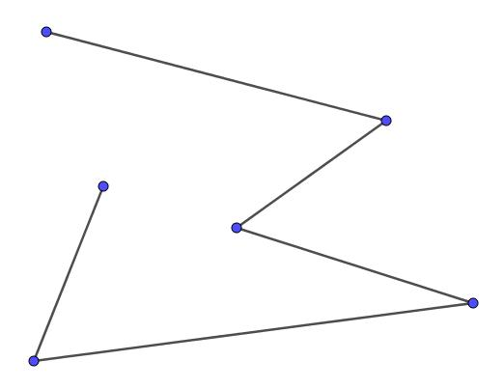

Definition
# Source: AI Source: Provided by: [Data Path: Persons Table -> ID Column: 1, Name_En Column: Motasem Essam] -> From: [ChatGPT] on [7/25/2026]
An Open Concave-Looking Polygonal Chain is an open chain of three or more connected straight-line segments that contains one or more pronounced inward turns or indentations, giving the overall chain a visual appearance similar to part of a concave polygon.
$$\boxed{\text{Open Concave-Looking Polygonal Chain}=\text{Straight Segments}+\text{Inward Turns}+\text{Open Boundary}}$$
Terminology note: In strict geometry, concavity is normally defined for a closed set or polygon. Therefore, an open chain is more precisely described as an inward-turning polygonal chain or concave-looking polygonal chain.

Characteristics
# Source: AI Source: Provided by: [Data Path: Persons Table -> ID Column: 1, Name_En Column: Motasem Essam] -> From: [ChatGPT] on [7/25/2026]
An Open Concave-Looking Polygonal Chain:
- Is open.
- Contains three or more straight segments.
- Has connected consecutive segments.
- Has two unconnected endpoints.
- Does not enclose an area.
- Contains at least one visually significant inward turn.
- May have unequal segment lengths.
- May have different turning angles.
- Can be symmetric or asymmetric.
- Can be simple or self-intersecting.
A simple representation is:
$$\boxed{A→B→C→D→E}$$
where one or more turns create an inward indentation.

Types of Open Concave-Looking Polygonal Chains

1. Simple Open Concave-Looking Chain
# Source: AI Source: Provided by: [Data Path: Persons Table -> ID Column: 1, Name_En Column: Motasem Essam] -> From: [ChatGPT] on [7/25/2026]
A basic open chain containing one clear inward turn.
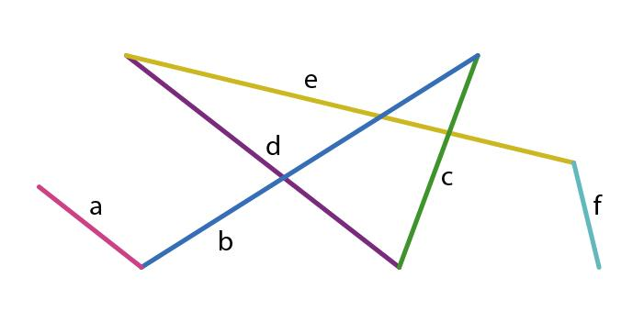
This is the simplest form of an inward-turning open chain.

2. Open Indented Polygonal Chain
# Source: AI Source: Provided by: [Data Path: Persons Table -> ID Column: 1, Name_En Column: Motasem Essam] -> From: [ChatGPT] on [7/25/2026]
The chain contains a pronounced inward indentation.
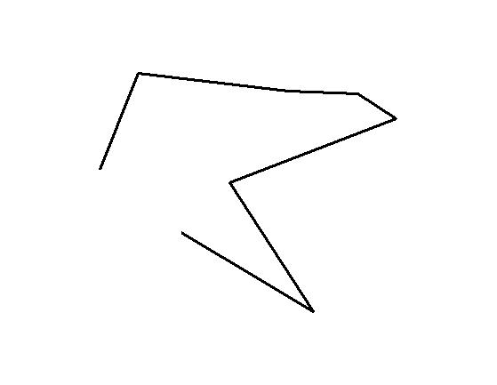
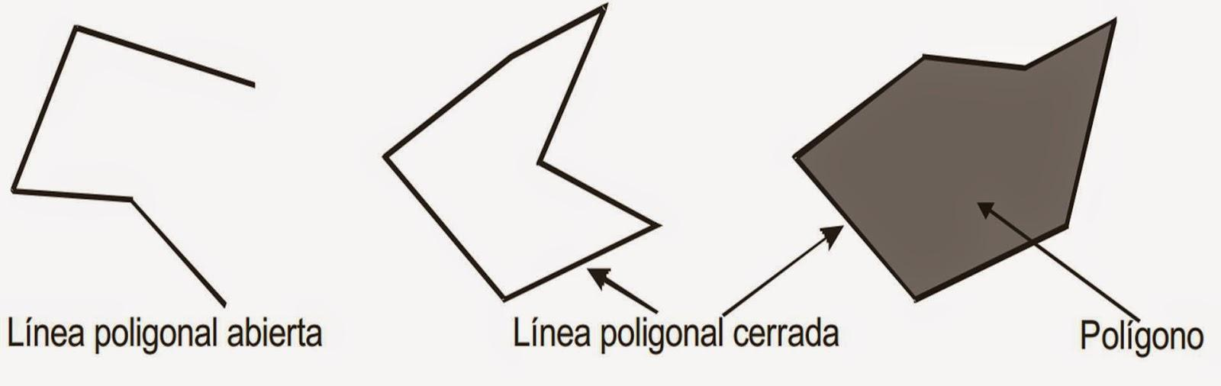
The indentation is the main feature distinguishing it from an outward-turning chain.

3. Open Concave-Looking Zigzag Chain
# Source: AI Source: Provided by: [Data Path: Persons Table -> ID Column: 1, Name_En Column: Motasem Essam] -> From: [ChatGPT] on [7/25/2026]
The chain follows a zigzag pattern with one or more turns directed inward.
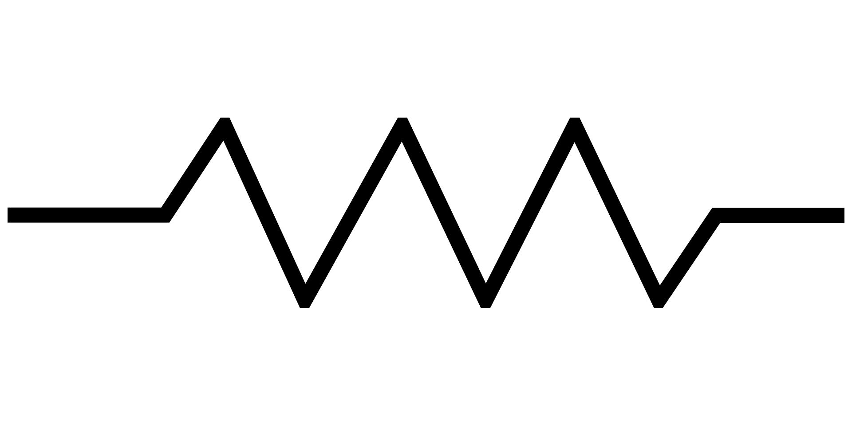
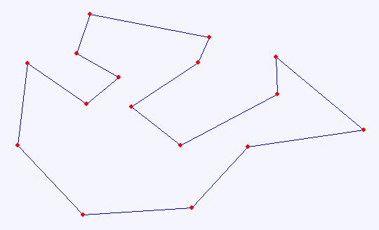
A zigzag chain can alternate between outward and inward turns.

4. Open Notched Polygonal Chain
# Source: AI Source: Provided by: [Data Path: Persons Table -> ID Column: 1, Name_En Column: Motasem Essam] -> From: [ChatGPT] on [7/25/2026]
A notch-like indentation occurs along the chain.
The notch can be shallow or deep.

5. Open U-Inward Polygonal Chain
# Source: AI Source: Provided by: [Data Path: Persons Table -> ID Column: 1, Name_En Column: Motasem Essam] -> From: [ChatGPT] on [7/25/2026]
The segments form a pronounced U-like inward region without closing the boundary.
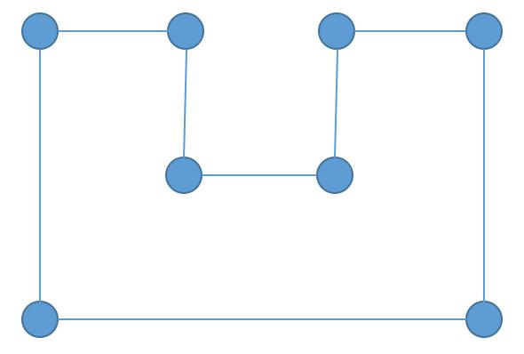
The endpoints remain separated.

6. Symmetric Open Concave-Looking Chain
# Source: AI Source: Provided by: [Data Path: Persons Table -> ID Column: 1, Name_En Column: Motasem Essam] -> From: [ChatGPT] on [7/25/2026]
The inward portion is arranged symmetrically around an axis.
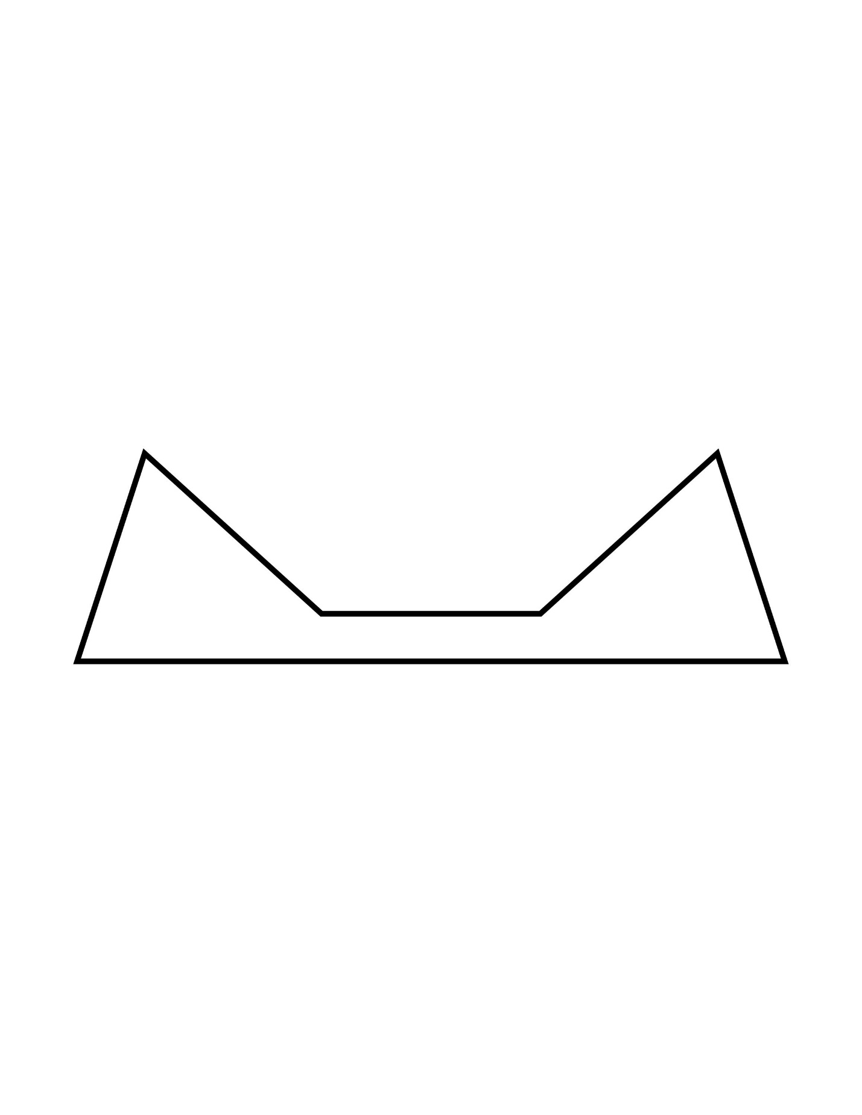
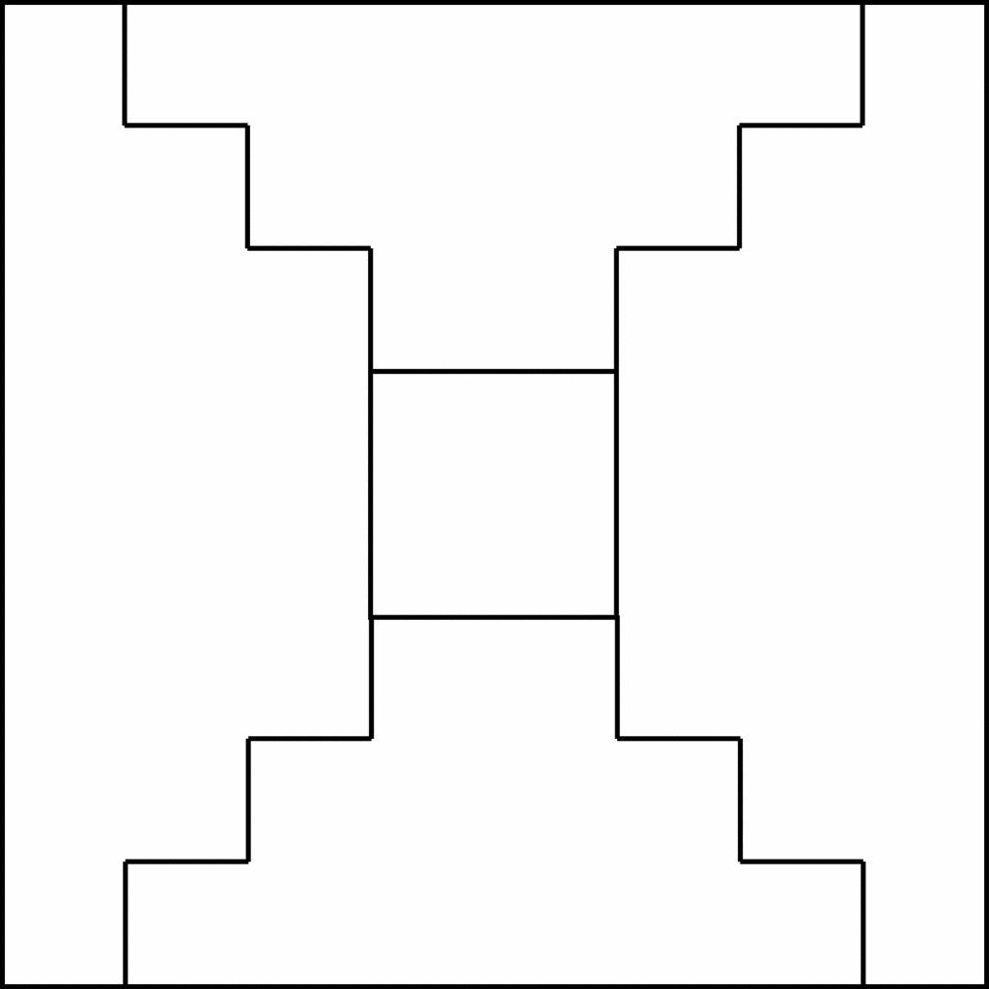
For example, the indentation can be centered around a vertical axis.

7. Asymmetric Open Concave-Looking Chain
# Source: AI Source: Provided by: [Data Path: Persons Table -> ID Column: 1, Name_En Column: Motasem Essam] -> From: [ChatGPT] on [7/25/2026]
The chain has an inward indentation but no regular symmetry.
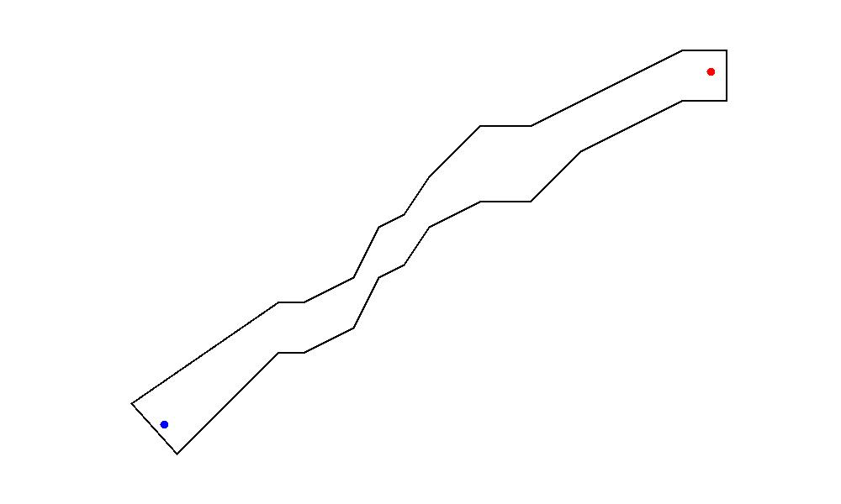
The two sides of the indentation can have different lengths and angles.

8. Multiple-Inward-Turn Open Chain
# Source: AI Source: Provided by: [Data Path: Persons Table -> ID Column: 1, Name_En Column: Motasem Essam] -> From: [ChatGPT] on [7/25/2026]
The chain contains several inward turns.
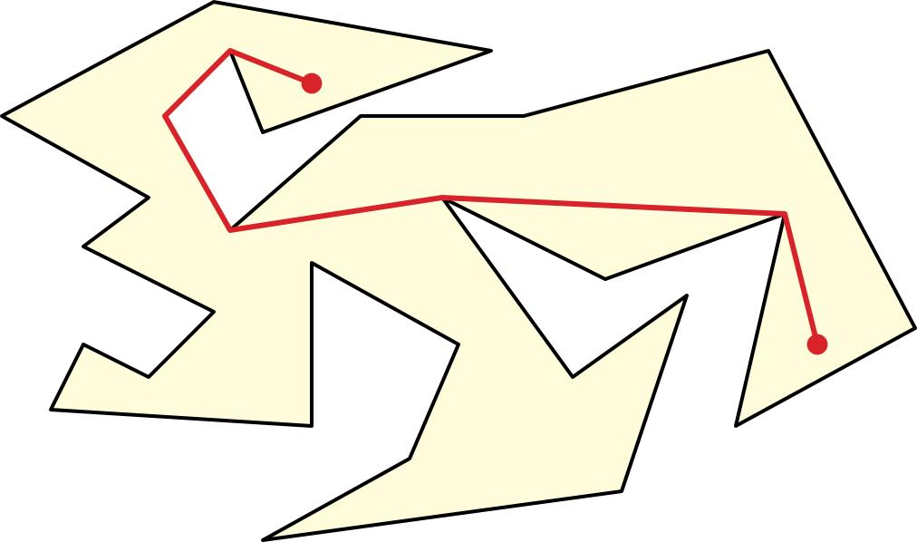
This produces a more complex concave-looking structure.

9. Open Rectilinear Concave-Looking Chain
# Source: AI Source: Provided by: [Data Path: Persons Table -> ID Column: 1, Name_En Column: Motasem Essam] -> From: [ChatGPT] on [7/25/2026]
The inward turns are formed entirely from horizontal and vertical segments.
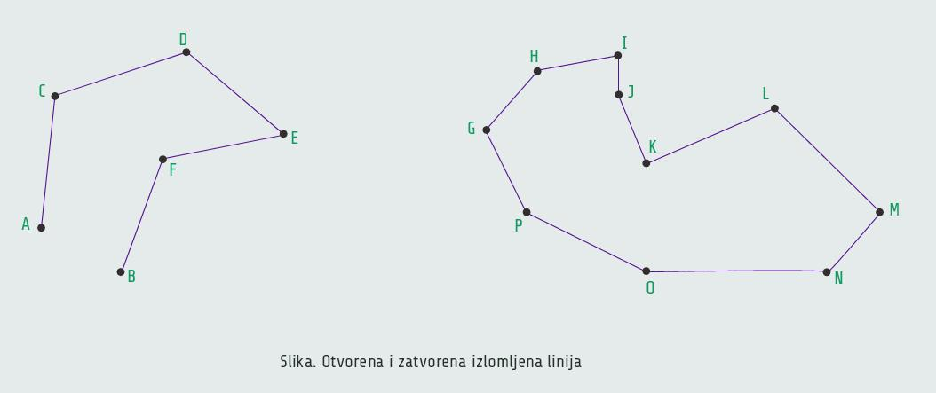
This is an orthogonal/rectilinear subtype.

10. Open Concave-Looking Self-Intersecting Chain
# Source: AI Source: Provided by: [Data Path: Persons Table -> ID Column: 1, Name_En Column: Motasem Essam] -> From: [ChatGPT] on [7/25/2026]
Some segments cross while the chain also contains inward turns.
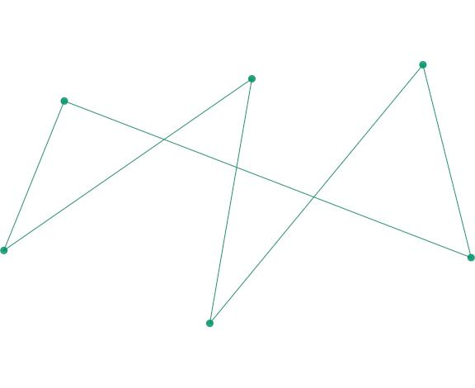
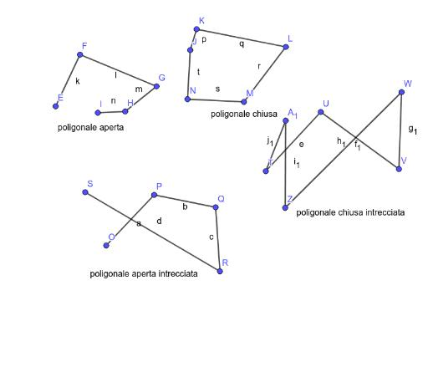
Because of the self-intersection, this becomes a more complex open polygonal network/path.

Concave-Looking vs. Convex-Looking Open Chains
# Source: AI Source: Provided by: [Data Path: Persons Table -> ID Column: 1, Name_En Column: Motasem Essam] -> From: [ChatGPT] on [7/25/2026]
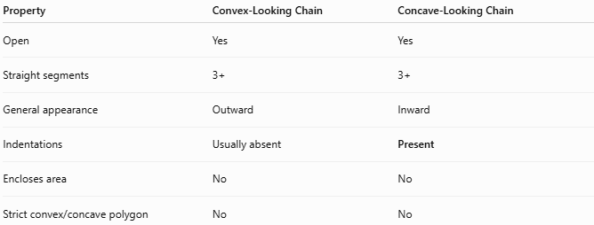
Property | Convex-Looking Chain | Concave-Looking Chain
Open | Yes | Yes
Straight segments | 3+ | 3+
General appearance | Outward | Inward
Indentations | Usually absent | Present
Encloses area | No | No
Strict convex/concave polygon | No | No
The distinction is based on the visual direction of the turns, since neither figure is a closed polygon.

Concave-Looking Chain vs. Closed Concave Polygon
# Source: AI Source: Provided by: [Data Path: Persons Table -> ID Column: 1, Name_En Column: Motasem Essam] -> From: [ChatGPT] on [7/25/2026]
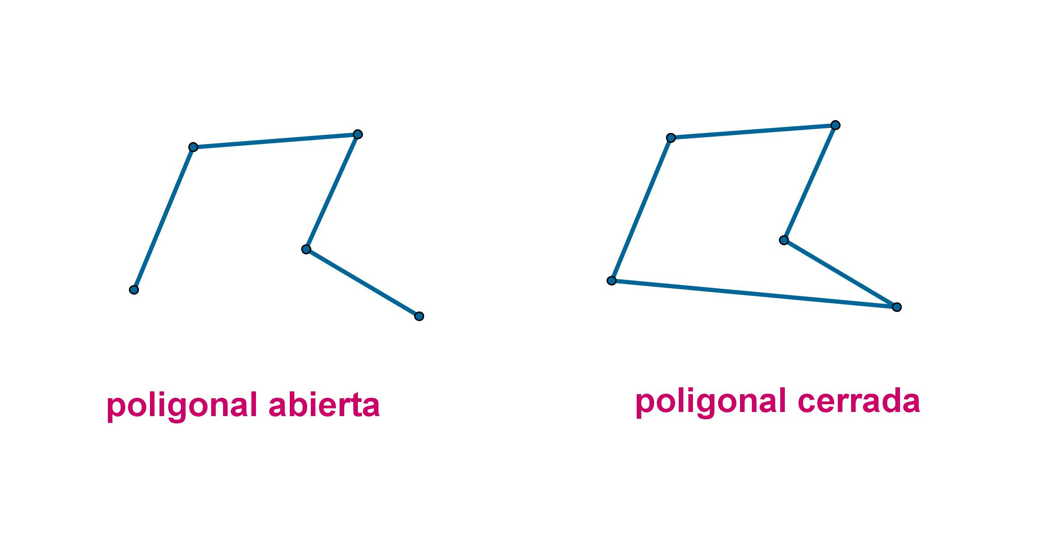
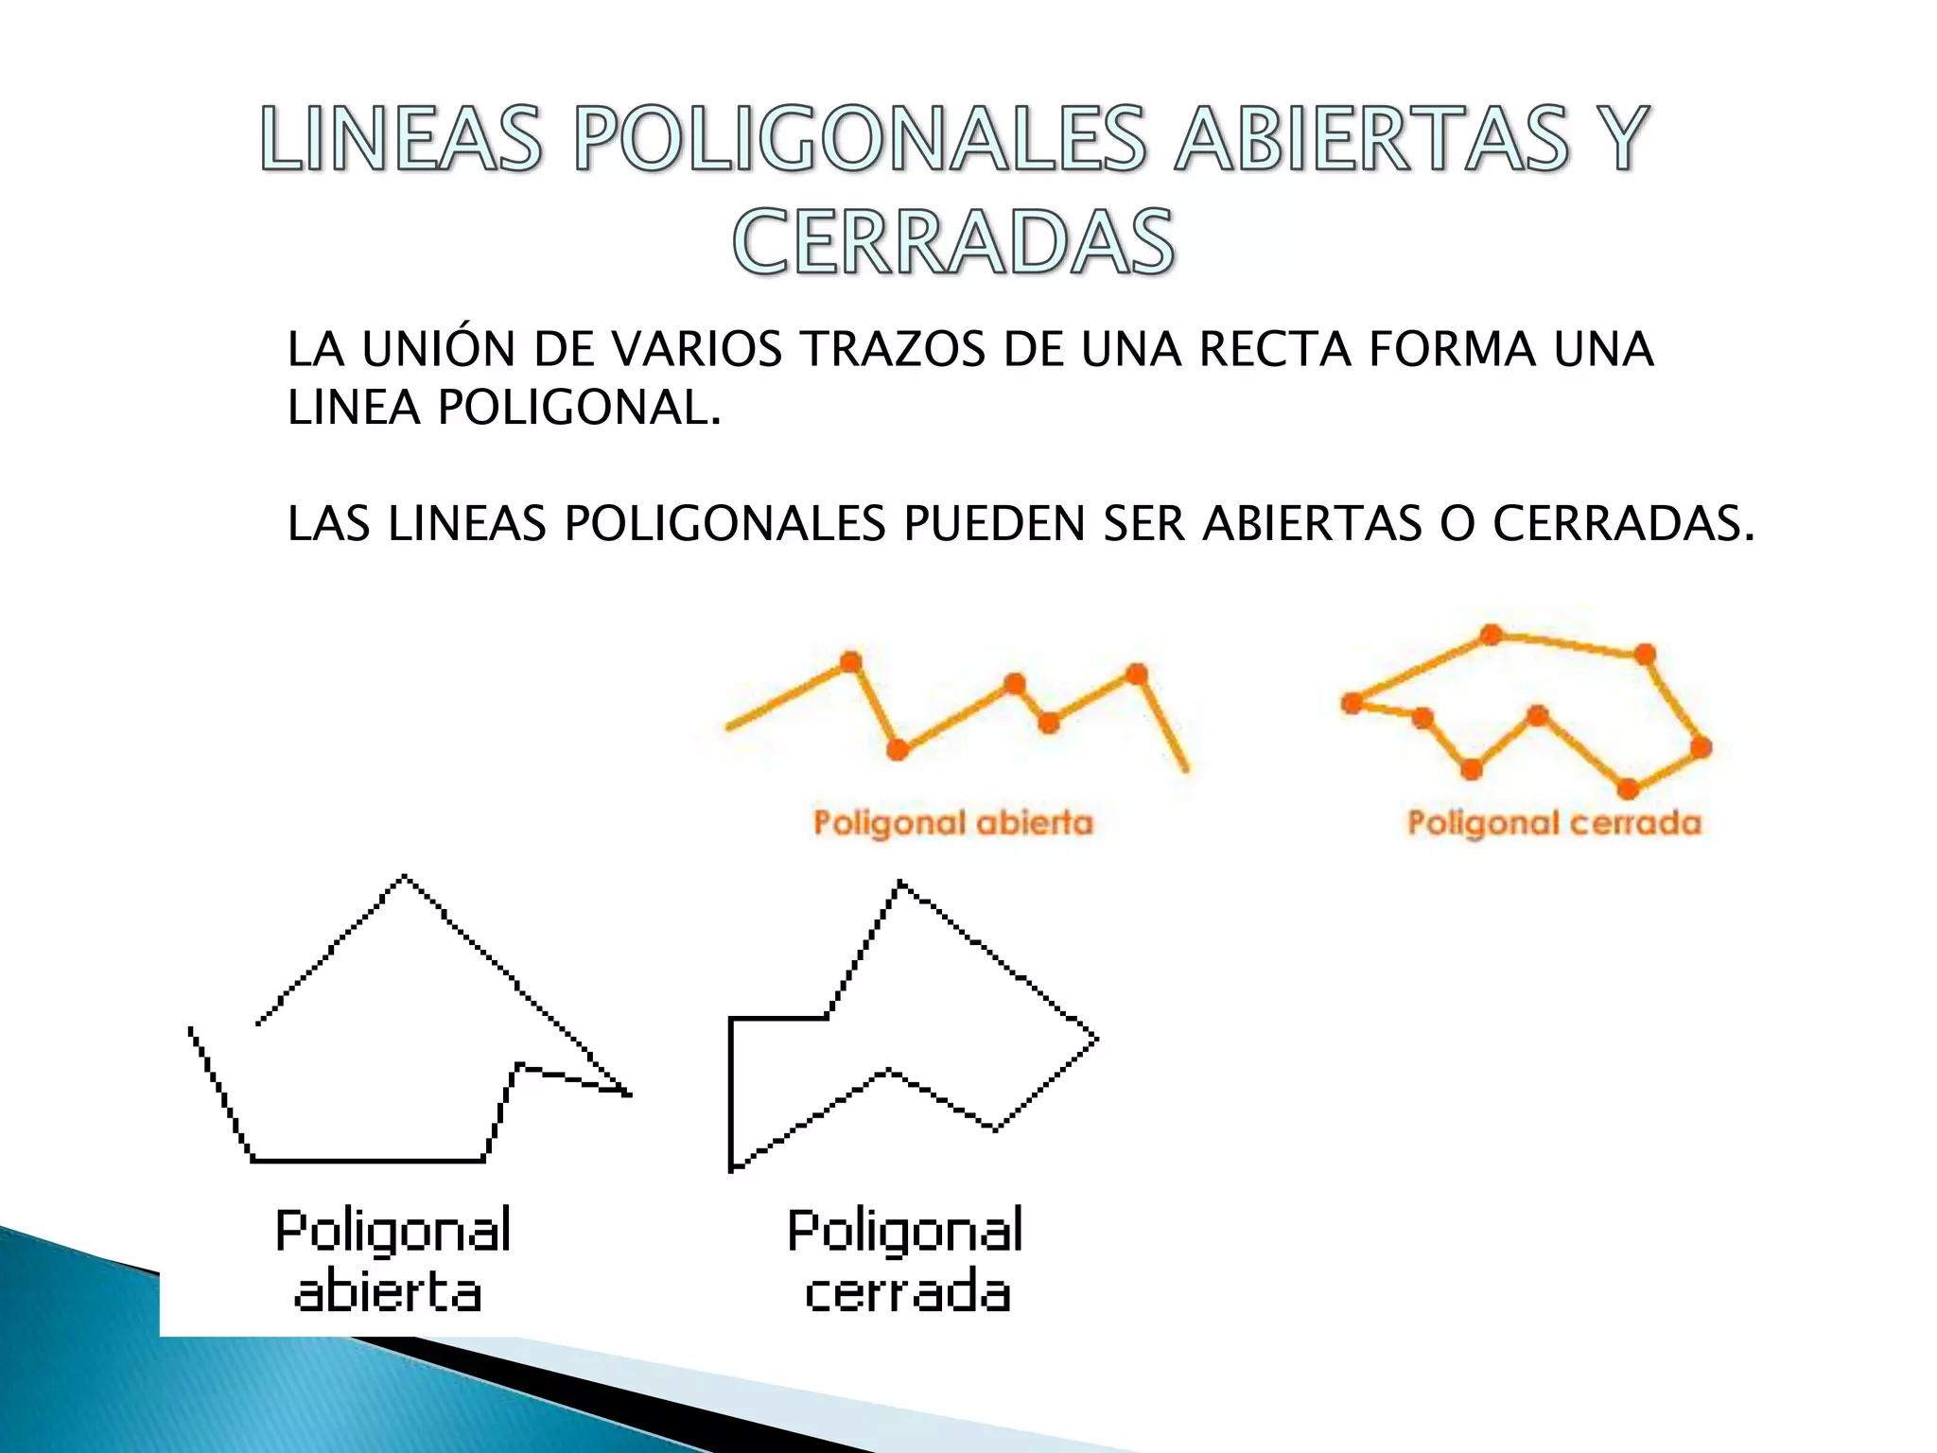
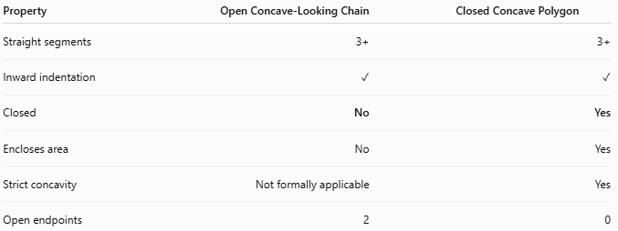
Property | Open Concave-Looking Chain | Closed Concave Polygon
Straight segments | 3+ | 3+
Inward indentation | ✓ | ✓
Closed | No | Yes
Encloses area | No | Yes
Strict concavity | Not formally applicable | Yes
Open endpoints | 2 | 0

Area and Length
# Source: AI Source: Provided by: [Data Path: Persons Table -> ID Column: 1, Name_En Column: Motasem Essam] -> From: [ChatGPT] on [7/25/2026]
Area
An open chain does not enclose a region:
$$\boxed{A=\text{no enclosed area}}$$
Total Chain Length
For $n$ segments:
$$\boxed{L=L_{1}+L_{2}+⋯+L_{n}}$$

Key Points
# Source: AI Source: Provided by: [Data Path: Persons Table -> ID Column: 1, Name_En Column: Motasem Essam] -> From: [ChatGPT] on [7/25/2026]
An Open Concave-Looking Polygonal Chain is:
$$\boxed{\text{Open}+\text{3 or More Straight Segments}+\text{One or More Inward Turns}}$$
It:
- Has three or more straight segments.
- Has two open endpoints.
- Does not enclose an area.
- Contains one or more visible inward turns or indentations.
- May be simple or self-intersecting.
- May be symmetric or asymmetric.
- May be rectilinear, zigzag, notched, or multi-indented.
- Is not formally a concave polygon, because it is open.
Most important distinction
$$\boxed{\text{Concave-Looking Open Chain}≠\text{Concave Polygon}}$$
The first is an open inward-turning polygonal chain, while the second is a closed polygon with a mathematically defined concavity.

Conclusion
# Source: AI Source: Provided by: [Data Path: Persons Table -> ID Column: 1, Name_En Column: Motasem Essam] -> From: [ChatGPT] on [7/25/2026]
Open Concave-Looking Polygonal Chains are open polygonal paths characterized by inward turns or indentations. They provide the open-chain counterpart to the visual idea of a concave polygon and can be further classified by their indentation pattern, symmetry, segment lengths, rectilinear structure, and self-intersection.

